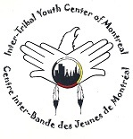
Inter-tribal Youth Centre of Montreal

PETITION
This petition is for the support of the Intertribal Youth Centre. Because the Native Friendship Centre of Montreal’s core funding has been suspended, it will likely force the closure of the Inter-Tribal Youth Centre within one week’s time.

This petition be will sent to the following organizations; The National Association of Friendship Centres, Regroupement des Centres d’Amitié Autochtones du Québec, Heritage Canada, Indian and Northern Affairs of Canada and Secrétariat des Affaires Autochtones du Québec.

We the undersigned support the full reinstatement of core funding for the Inter-Tribal Youth Center of Montreal, under the Cultural Connections for Aboriginal Youth Program.

Name | Email Address | Nation | Signature

